With the poles in place, using a theodolite or total station, survey a point on each pole that is at the same height (1-2m above the center). Install eye-bolts at those positions and attached the centering jig (~8m kevlar lines with springs attached to a ring – see phtotos).

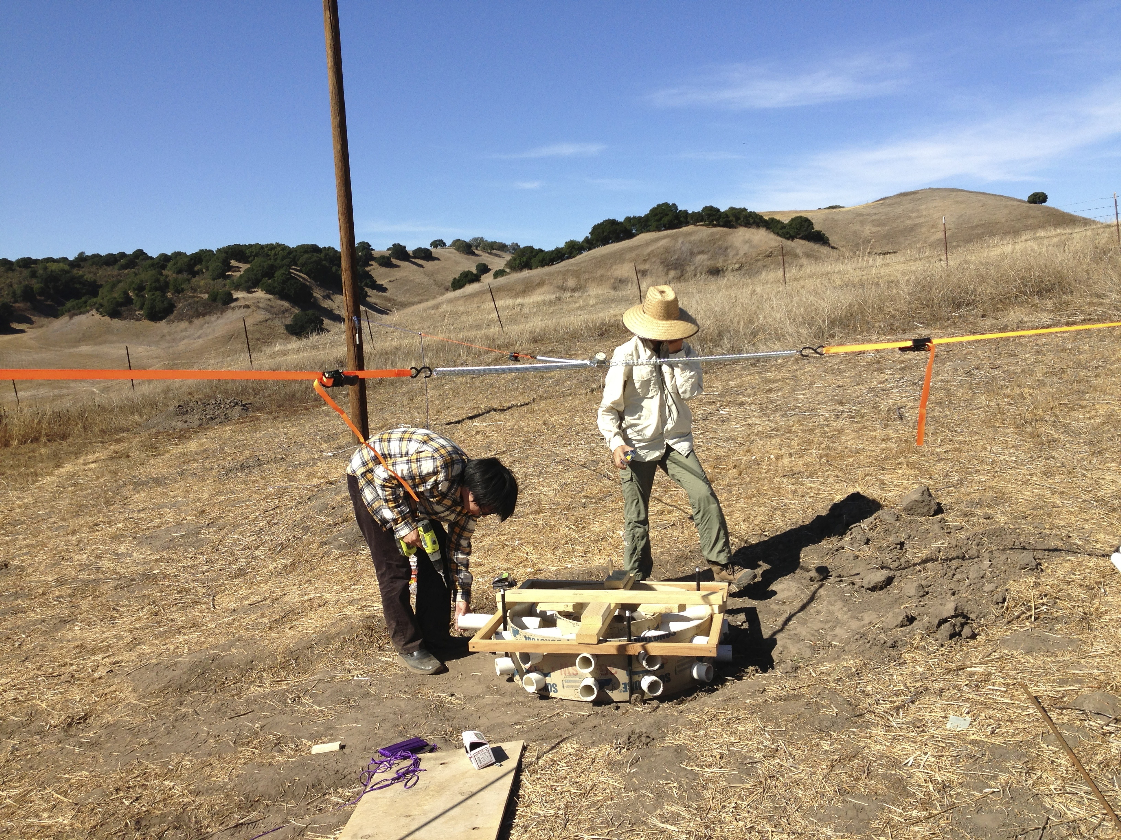

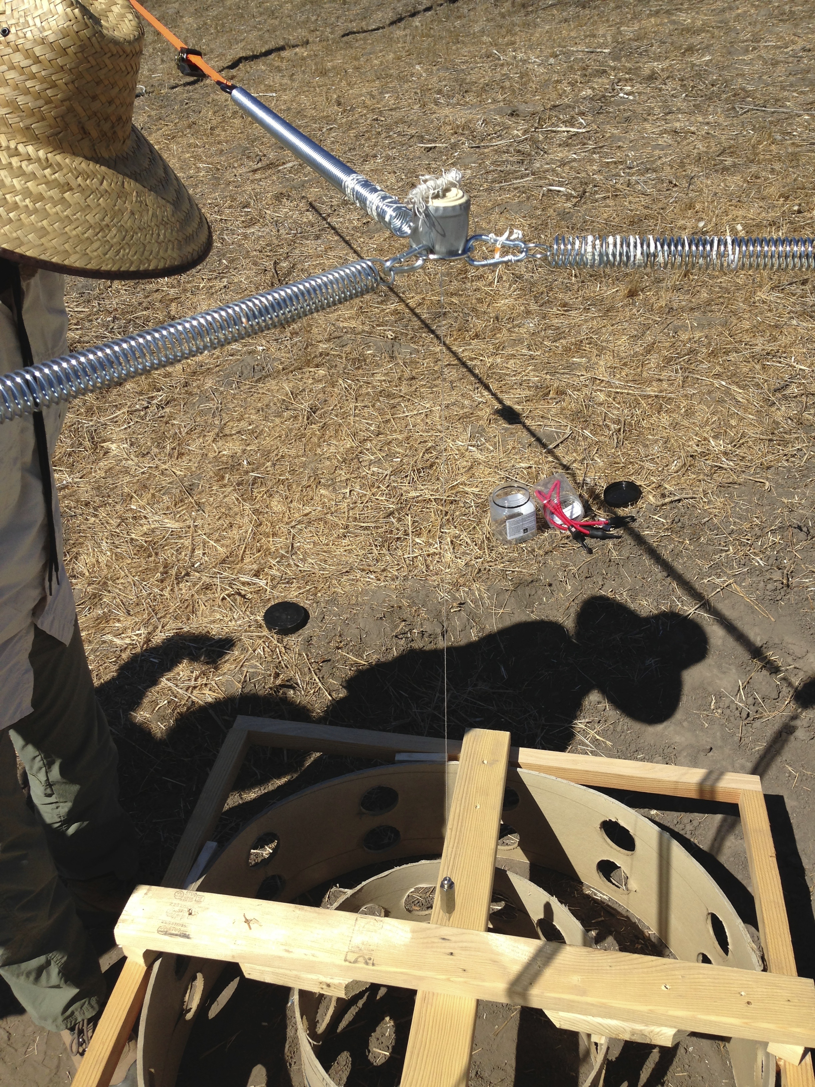

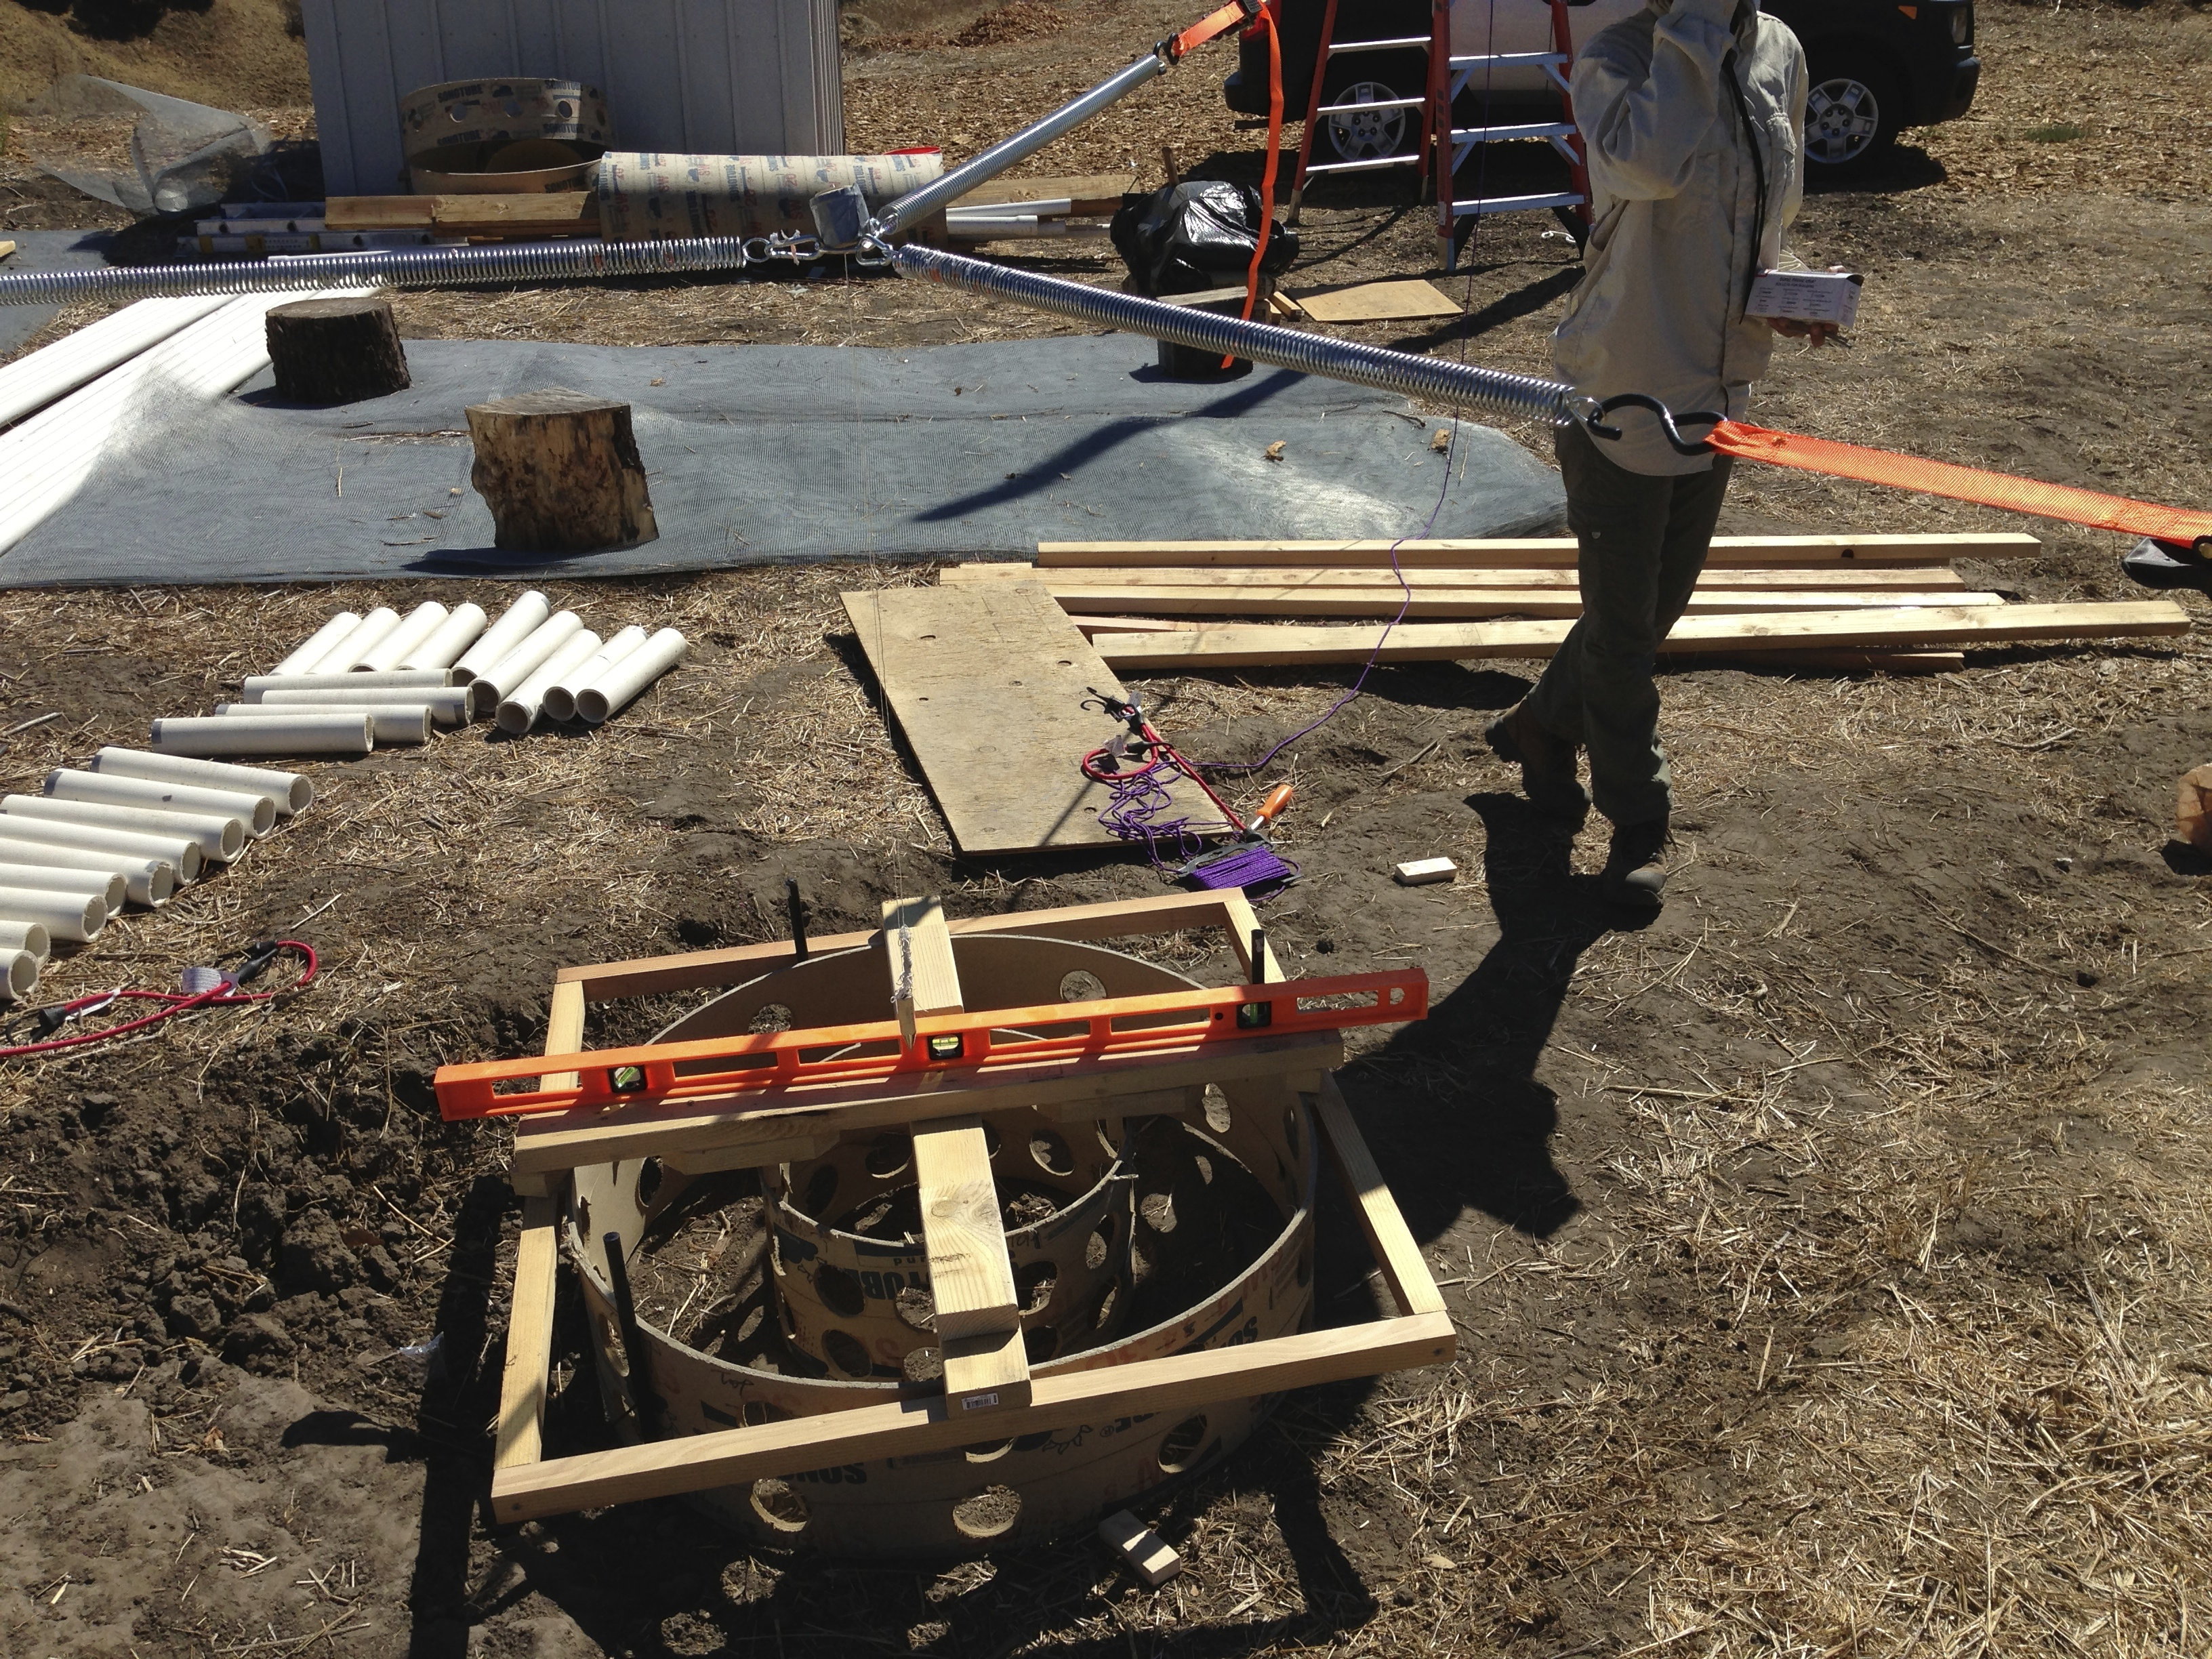

Hang plumb bob through ring – this is the center of the antenna.

Set up the sonotube and the hub jig under the center point and insert the support spars and sleeves. Level the sonotube/jig and align the spars with the centering jig lines.

Pour the concrete.

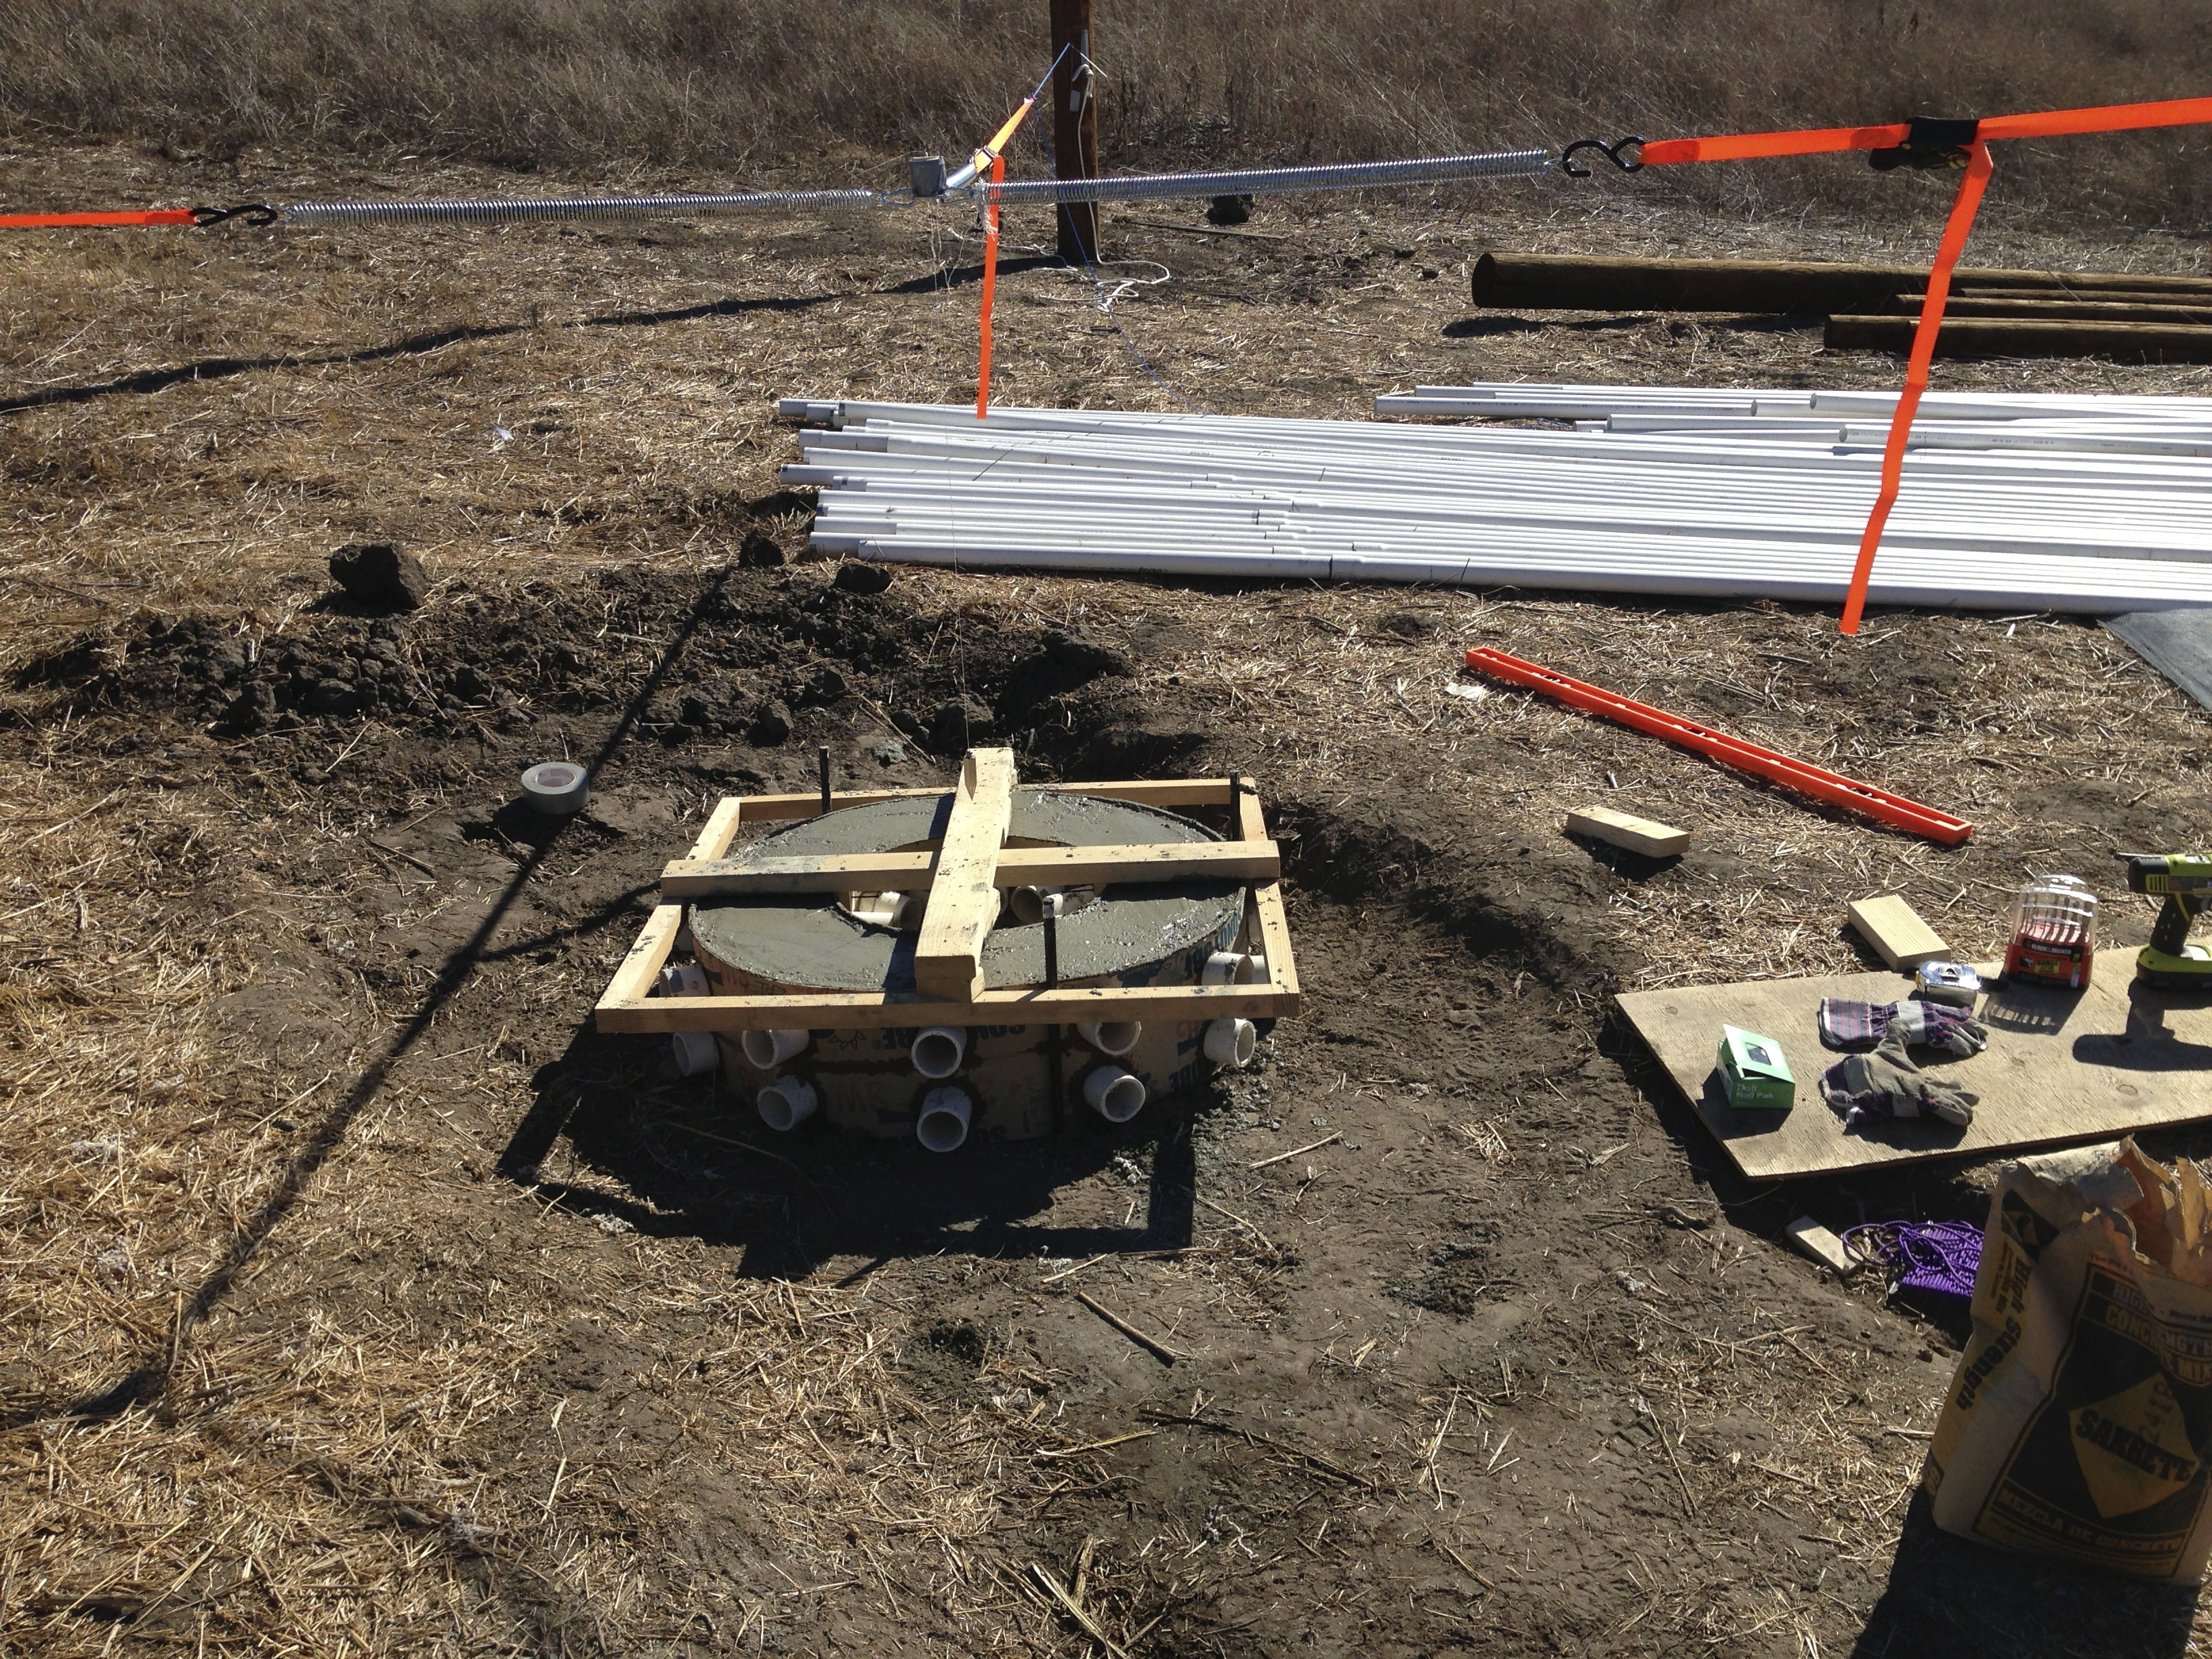

Note that in this picture, the bottom ring of pvc are sleeves, whereas in the new ones they are the full length horizontal spars.